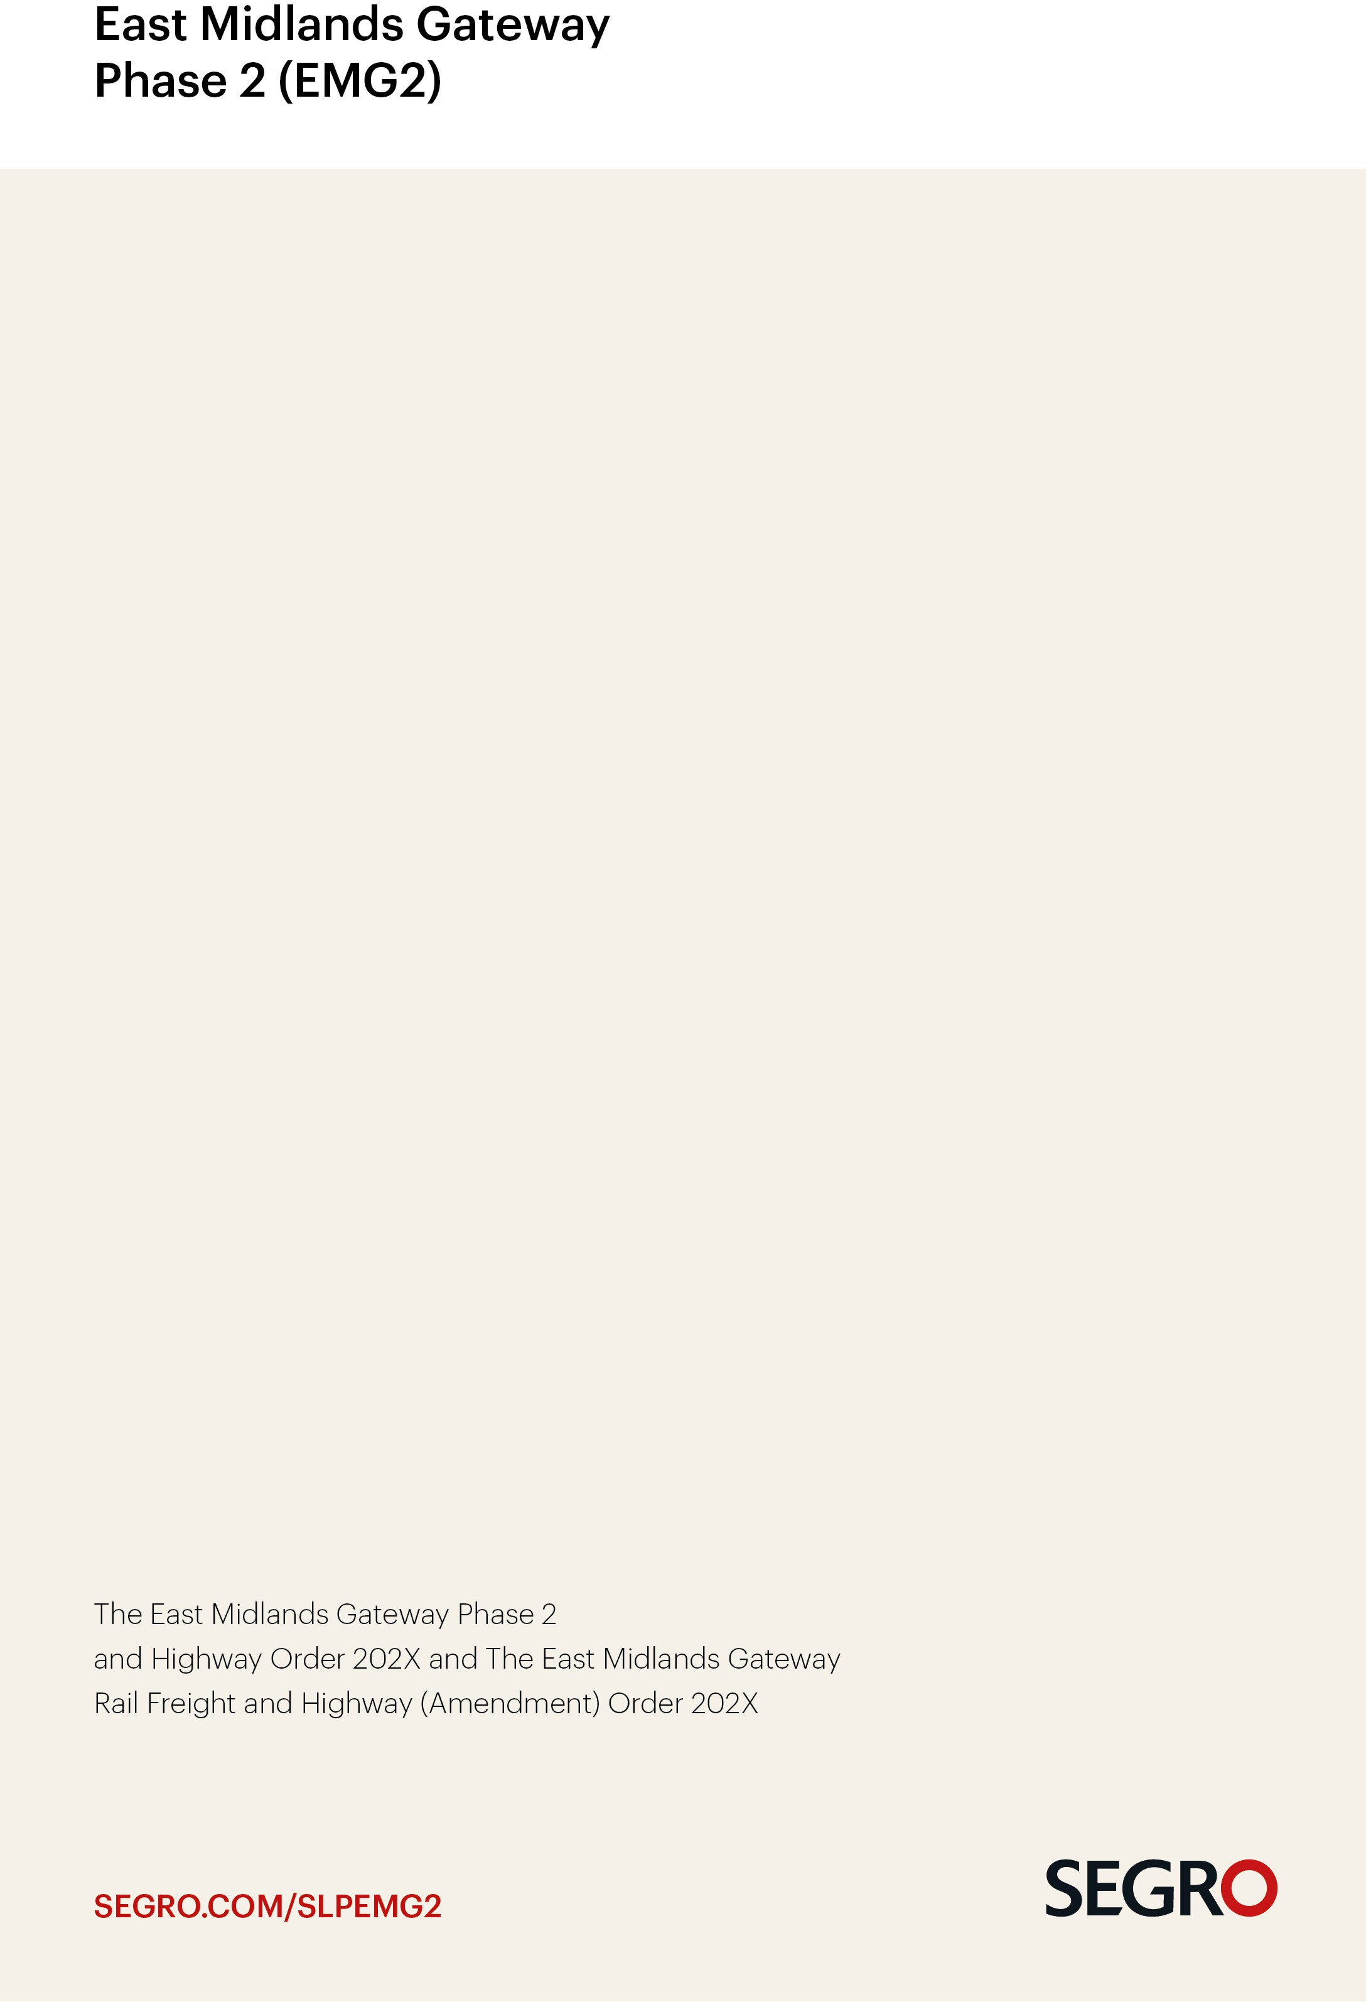Programme

June 2025

**CONTENTS**

|  |  |
| --- | --- |
| **No. Item** | **Page** |
| **1. Introduction** | **3** |
| **2. Date for submission** | **3** |
| **3. Statement of Community Consultation** | **3** |
| **4. Engagement with statutory consultees and stakeholders** | **3** |
| **5. Project Timeline** | **4** |
| **6. Tabular Programme** | **5** |

**EMG2 APPLICATION PROGRAMME**

**(UPDATED AS AT 17 JUNE 2025)**

1. **Introduction**

This programme document has been prepared having regard to with the non-statutory guidance published by the Planning Inspectorate (PINS) on the pre-application stage for Nationally Significant Infrastructure Projects as it applies to the standard tier service.

The programme focuses on the pre-application period up to submission and is comprised of two sections. The first section contains a project timeline for the programme representing a simplified summary of the project milestones and events in the preparation of the application. A version of the project timeline has been published by SEGRO (the "Applicant") on its EMG2 webpage since that page went live in November 2024, to keep members of the public and interested parties informed of relevant project milestones. Earlier iterations of this programme document have been provided to and regularly updated for the Planning Inspectorate.

The second section contains a tabular programme which includes additional notes and the identification of the key statutory milestones during the pre-application period which are denoted by **\*KM\*** in bold. The tabular programme also provides provisional estimated dates for the examination and determination periods based on the anticipated application submission date.

1. **Date for Submission of the DCO and MCO Applications**

The Applicant intends to submit the DCO and MCO applications simultaneously in **Q3 2025**. This programme has been tailored accordingly and reflects the advanced work and engagement with stakeholders already undertaken.

1. **Statement of Community Consultation (SoCC)**

The Applicant published the SoCC on 18 December 2024 both on the Applicant's EMG2 webpage and in local newspapers circulating in the vicinity of the site. The SoCC was therefore published well in advance of the 6 week statutory consultation period held between 3 February and 17 March 2025.

1. **Engagement with statutory consultees and local authorities**

The Applicant has and continues to engage with statutory consultees and has put in place fee funding arrangements with statutory consultees including the Environment Agency and Natural England. In addition, the Applicant has completed a Planning Performance Agreement (PPA) with both North West Leicestershire District Council and Leicestershire County Council. These arrangements further support the Applicant's confidence in securing the engagement it requires during the pre-application period and achieving the timescales in this programme.

**Section 1 – Project timeline to submission**

**Section 2 – Tabular programme**

|  | **KEY STAGE** | **DATE / PERIOD** | **NOTES / ASSUMPTIONS** |
| --- | --- | --- | --- |
|  | s.35 submission to DLUHC. | 22 January 2024 | **Complete** |
|  | Decision of DLUHC on s.35 application. | 21 February 2024 | **Complete** |
|  | Inception meeting with PINS. | 13 May 2024 | **Complete** |
|  | Instruct land referencers and commence desktop land referencing. | May and June 2024 | **Complete** |
|  | Ongoing non-statutory consultation/engagement with key stakeholders and landowners as required. | June to December 2024 and Ongoing as required. | The Applicant is capturing engagement in a consultation log to be included in its Consultation Report. |
|  | **\*KM\*** Prepare and submit re-scoping request to PINS | August 2024 | **Complete**  PINS Scoping Opinion issued 24 September 2024. |
|  | Land referencers commence contact referencing to conclude identification of all category 1, 2 and 3 interests. | August 2024 to January 2025 | **Complete**.  LIQs prepared and to be sent out in January 2025 prior to statutory consultation. |
|  | **\*KM\*** Consult with Local Authorities (District and County Council) on Statement of Community Consultation (SOCC). | October 2024 | **Complete**  Draft SoCC submitted to LAs in October 2024.LAs responses taken into consideration and revised SoCC published 18 December 2024. |
|  | Preparation of document pack for statutory consultation. | November to January 2025 | **Complete**  Statutory consultation held 3 February 2025 to 17 March 2025 and included draft ES chapters (constituting the Preliminary Environmental Information). |
|  | **\*KM\*** Undertake statutory consultation. | 3 February to 17 March 2025 | **Complete**  Allowed 6 weeks, more than the minimum 28 days, for responses. |
|  | **\*KM\*** Submission of draft documentation to PINS. | February 2025 | **Complete**  PINS response received 1 April 2025. |
|  | **\*KM\*** submit Adequacy of Consultation statement to PINS. | 28 April 2025 | **Complete**  Adequacy of Consultation published on PINS website and SEGRO EMG2 webpage. |
|  | Consideration of consultation responses and publication on SEGRO webpage of summary of main themes arising from consultation responses. | March to April 2025 | **Complete** |
|  | Refining proposals for EMG2 and preparation of application documentation | Ongoing to June/July 2025 | Draft application documentation will be the subject of non-statutory consultation in July 2025 |
|  | Non-statutory consultation on draft application documentation. | June/July 2025 | 4 week consultation period. |
|  | Regular meetings with PINS case officer. | Ongoing to submission | As required. To discuss progress with application preparation and any issues arising. |
|  | **\*KM\*** DCO and MCO applications submitted. | From late July 2025 | Applications to be submitted simultaneously. |
|  | Applications accepted for Examination. | TBC (Potentially September 2025) | DCO 28 days after submission.  MCO typically 21 days after submission. |
|  | Preliminary Meeting and start of Examination. | TBC (Potentially December 2025) | The Secretary(ies) of State may choose to co-join the DCO and MCO applications and examine them together.  An examination will be required for the DCO because it involves compulsory purchase powers. However, SEGRO owns all of the MCO land and it is open to the Secretary(ies) of State to determine the MCO application without the need for an examination. |
|  | End of Examination. | TBC (Potentially June 2026) | Assumes up to 6 months for examination.  DCO examination is up to 6 months.  MCO examination is ordinarily 4 months but could be co-joined with the DCO at the discretion of the Secretary(ies) of State. |
|  | Inspector's Report written and sent to Secretary(ies) of State. | TBC (Potentially September 2026) | DCO 3 months from end of Examination.  MCO 2 months from the end of examination, unless co-joined. |
|  | Consideration of Inspector's Report and decision by Secretary(ies) of State. | TBC (Potentially December 2026) | DCO 3 months from receipt of Inspector's Report.  MCO 2 months from receipt of Inspector's Report, unless co-joined |